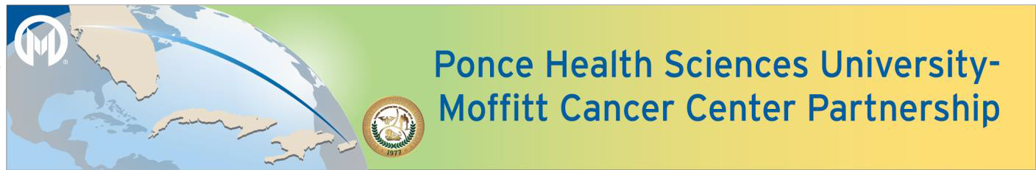

2021 U54 Competitive Renewal Funding Opportunity
Pre-Proposal Application
DUE DATE: Monday, March 1, 2021 at 5 pm

1. PRINCIPAL INVESTIGATOR
NAME (Last, first, middle) | INSTITUTION: MCC PHSU
 | E-MAIL:
Do you need assistance identifying a collaborator? Yes No
If no, please complete the below information.
NAME (Last, first, middle) | INSTITUTION: MCC PHSU
 | E-MAIL:

TITLE OF PROJECT

3. Do you feel your project best fits a: Pilot Project ($60,000 per institution per year up to 3 years)

4. Do you feel your project best fits a: Full Project ($137,500 per institution per year up to 3 years)
_________________________________________ ____________  MCC MPI SIGNATURE DATE | _________________________________________ ____________  PHSU MPI SIGNATURE DATE

LAY ABSTRACT: (20 lines maximum)
Please provide a brief summary of your project that would be suitable for sharing with a broad audience (e.g., community members, patients, donors) that focuses on the significance of the work proposed. Please avoid the use of jargon and explain any technical terms that must be included.

SPECIFIC AIMS (1 page maximum)
This should include the project’s relatedness to the overall goals of the U54 Partnership. More information on the Partnership goals, resources and accomplishments: http://www.phsu-moffitt.org/.
FEASIBILITY JUSTIFICATION (1 page maximum)
This may include preliminary data or any previous work that demonstrates feasibility to complete the study aims (e.g., prior work with the population, access to participants/samples, expertise of investigators, or preliminary data).

